 

## Title:

**ROAD ACCIDENT PREVENTION USING MACHINELEARNING**

**A CORE COURSE PROJECT REPORT**

**Submitted By**

**A.MUJEEB REG NO. 23CS002**

**M.BHAVAN KUMAR REG NO. 23CS023**

**in partial fulfillment for the award of the degree of**

##### BACHELOR OF ENGINEERING

**IN**

**COMPUTER SCIENCE AND ENGINEERING**



**DEPARTMENT OF COMPUTER SCIENCE AND ENGINEERING**

##### CHENNAI INSTITUTE OF TECHNOLOGY

**(Autonomous)**

###### Sarathy Nagar, Kundrathur, Chennai-600069

OCT / NOV – 2024



**Vision of the Institute:**



To be an eminent centre for Academia, Industry and Research by imparting knowledge,Relevant practices and inculcating human values to address global challenges through novelty and sustainability *.*

**Mission of the Institute:**



***IM1****.To* ***creates*** *next generation leaders by effective teaching learning*

*methodologiesand instill scientific spark in them to meet the global challenges.*

***IM2****.To transform lives through deployment of emerging technology, novelty and sustainability.*

***IM3****.To inculcate human values and ethical principles to cater the societal needs.*

***IM4****.To contributes towards the research ecosystem by providing a suitable, effectiveplatform for interaction between industry, academia and R & D establishments.*



**DEPARTMENT OF**

## COMPUTER SCIENCE AND ENGINEERING

**Vision of the Department**:



*To Excel in the emerging areas of Computer Science and Engineering by imparting knowledge, relevant practices and inculcating human values to transform the students as potential resources to contribute innovatively through advanced computing in real time situations.*

**Mission of the Department**:



***DM1.*** *To provide strong fundamentals and technical skills for Computer Science*

*applications through effective teaching learning methodologies.*

***DM2.*** *To transform lives of the students by nurturing ethical values, creativity and novelty to become Entrepreneurs and establish start-ups.*

***DM3.*** *To habituate the students to focus on sustainable solutions to improve the*

*quality of life and the welfare of the society.*



## CERTIFICATE

This is to certify that the “**Core Course Project**” Submitted by **Name: M.BHAVAN KUMAR (Reg no:23CS023** and **Name: A.MUJEEB Reg no:23CS002** is a work done by him/her and submitted during **2023-2024** academic year, in partial fulfilment of the requirements for the award of the degree of **BACHELOR OF ENGINEERING** in **DEPARTMENT OF COMPUTER SCIENCE AND**

**ENGINEERING**, at Chennai Institute of Technology.

**Project Coordinator**

(Name and Designation)

**Internal Examiner**

**Head of the Department**

(Name and Designation)

**External Examiner**

##### ACKNOWLEDGEMENT

We express our gratitude to our Chairman **Shri.P.SRIRAM** and all trust members of Chennai institute of technology for providing the facility and opportunity to do this project as a part of our undergraduate course.

We are grateful to our Principal **Dr.A.RAMESH M.E**, **Ph.D.** for providing us the facility and encouragement during the course of our work.

We sincerely thank our Head of the Department **Dr.A.Pavithra,** Department of Computer Science and Engineering for having provided us valuable guidance, resources and timely suggestions throughout our work.

We would like to extend our thanks to our Project Co-ordinator of the **Dr.R.P Ponnusamy,** Department of Computer Science and Engineering, for his valuable suggestions throughout this project.

We wish to extend our sincere thanks to all Faculty members of the Department of Computer Science and Engineering for their valuable suggestions and their kind cooperation for the successful completion of our project.

We wish to acknowledge the help received from the **Lab Instructors of the** Department of Computer Science and Engineering and others for providing valuable suggestions and for the successful completion of the project.

**NAME:A.MUJEEB/M.BHAVAN KUMAR REG.NO:23CS002/23CS023**

##### PREFACE

I, a student in the Department of Computer Science and Engineering need to undertake a project to expand my knowledge. The main goal of my Core Course Project is to acquaint me with the practical application of the theoretical concepts I’ve learned during my course.

It was a valuable opportunity to closely compare theoretical concepts with real- world applications. This report may depict deficiencies on my part but still it is an account of my effort.

The results of my analysis are presented in the form of an industrial Project, and the report provides a detailed account of the sequence of these findings. This report is my Core Course Project, developed as part of my 2nd year project. As an engineer, it is my responsibility to contribute to society by applying my knowledge to create innovative solutions that address their changes.

**ABSTRACT**

Roadaccidentsareasignificant cause of fatalities and injuries worldwide. Predicting road accidents is crucial forimplementing preventive

measures and savinglives. This paper presentsadeeplearning- basedroadaccident prediction system utilizing various factorssuch asspeed,trafficcondition,weather,andmore.Byleveraging publiclyavailabledatasetsandexternal

data sources, the model aims to accurately predict road accidents, ultimately contributing to enhancing road safety.Keywords:Road Accidents, Machine Learning, Traffic Prediction, Accident Prevention

**LIST OF FIGURES**

### FIGURE NO

**TITLE**

1. INTRODUCTION
2. REVIEW
3. METHODOLOGY
4. ROAD ACCIDENT DATA SOURCE
5. TOOLS AND TECHNIQUE
6. FINAL RESULT
7. CONCLUSION
8. REFERENCE

### CHAPTER 1 INTRODUCTION

Road Traffic Accidents (RTA) are a global menace, causing countless fatalities and injuries annually despite regulatory efforts. Predicting RTAs remains a daunting

challenge due to multifaceted influencing factors.

This paper aims to address this issue by creating

an interactive traffic accident predictor embedded in a user-friendly web interface. By analyzing various parameters, the system will offer route suggestions and

identify accident-prone areas, empowering users with real- time insights.Utilizing advanced technologies like machine learning and data analytics, this system will leverage diverse datasets encompassing traffic flow, weather conditions, and historical accident data.

Through sophisticated algorithms, it will forecast the likelihoodof RTAs in specific locations and timeframes, aiding both individuals and authorities in making informed decisions and implementing targeted interventions.The proactive approach of this interactive system holds the

potential

to significantly reduce RTA incidence and mitigate associated human toll.

By harnessing technology and data-driven insights, it strives towards a future of enhanced road safety and resilience in transportation system

### Importance of Machine Learning

Machine learning is important because it gives enterprises a view of trends in customer behaviour and business operational patterns, as well as supports the development of new products. Many of today's leading companies, such as Facebook, Google and Uber, make machine learning a central part of their operations.

### Machine Learning Process

Machine learning workflow refers to the series of stages or steps involved in the process of building a successful machine learning system.

The various stages involved in the machine learning workflow are-

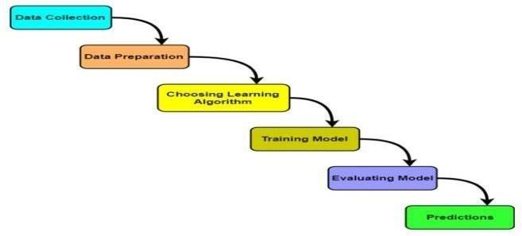

Figure 1.1 Machine Learning Process

### Figure 1.2 Machine Learning Process Data Collection- In this stage,

Data is collected from different sources.The type of data collected depends upon the type of desired project.Data may be collected from various sources such as files, databases etc.The quality and quantity of gathered data directly affects the accuracy of the desired system.

### Data Preparation- In this stage,

Data preparation is done to clean the raw data.Data collected from the real world is transformed to a clean dataset.

Raw data may contain missing values, inconsistent values, duplicate instances etc.So, raw data cannot be directly used for building a model.

**Choosing Learning Algorithm- In this stage,**

The best performing learning algorithm is researched.It depends upon the type of problem that needs to solved and the type of data we have.If the problem is to classify and the data is labeled, classification algorithms are used.

If the problem is to perform a regression task and the data is labeled, regression algorithms are used.

If the problem is to create clusters and the data is unlabeled, clustering algorithms are used.

**Training Model-** In this stage,

The model is trained to improve its ability.The dataset is divided into training dataset and testing dataset.

The training and testing split is order of 80/20 or 70/30.It also depends upon the size of the dataset.Training dataset is used for training purpose.Testing dataset is used for the testing purpose.

* 1. Types of Machine Learning

There are 3 types of Machine Learning

* + 1. Supervised Machine Learning
    2. Unsupervised Machine Learning
    3. Reinforcement Machine Learning

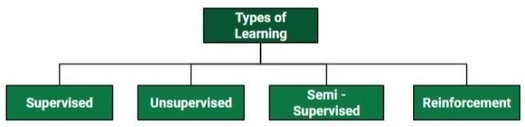

Figure 1.2 Types of Machine Learning

* 1. **Supervised Machine Learning** :

Supervised machine learning is based on supervision. It means in the supervised learning technique, we train the machines using the "labelled" dataset, and based on the training, the machine predicts the output. Here, the labelled data specifies that some of the inputs are already mapped to the output. More preciously, we can say; first, we train the machine with the input and corresponding output, and then we ask the machine to predict the output using the test dataset.

Supervised machine learning can be classified into two types of problems, which are given below:

#### Classification : Classification algorithms are used to solve the classification problems in which the output variable is categorical, such as "Yes" or No, Male or Female, Red or Blue, etc

Regression : Regression algorithms are used to solve regression problems in which there is a linear relationship between input and output variables. These are used to predict continuous output variables, such as market trends, weather prediction, etc.

Unsupervised Machine Learning :

In unsupervised learning, the models are trained with the data that is neither classified nor labelled, and the model acts on that data without any supervision.

The main aim of the unsupervised learning algorithm is to group or categories the unsorted dataset according to the similarities, patterns, and differences.

Unsupervised Learning can be further classified into two types, which are given below:

Clustering : The clustering technique is used when we want to find theinherent groups from the data. It is a way to group the objects into a cluster such that the objects with the most similarities remain in one group and have fewer or no similarities with the objects of other groups.

Association : Association rule learning is an unsupervised learning technique, which finds interesting relations among variables within a large dataset. The main aim of this learning algorithm is to find the dependency of one data item on another data item and map those variables accordingly so that it cangenerate maximum profit.

* 1. **Reinforcement Machine Learning :**

Reinforcement learning works on a feedback-based process, in which an AI agent (A software component) automatically explore its surrounding by hitting & trail,

taking action, learning from experiences, and improving its performance. Reinforcement learning is categorized mainly into two types of methods/algorithms:

Positive Reinforcement Learning: Positive reinforcement learning specifies increasing the tendency that the required behaviour would occur again by adding something. It enhances the strength of the behaviour of the agent and positively impacts it.

Negative Reinforcement Learning: Negative reinforcement learning works exactly opposite to the positive RL. It increases the tendency that the specific behaviour would occur again by avoiding the negative condition

### CHAPTER -2 LITERATURE

**REVIEW**

### 2 LITERATURE SURVEY:

|  |  |  |  |  |  |  |  |
| --- | --- | --- | --- | --- | --- | --- | --- |
| Researchers | such | as | Dr. | Priya | Sharma, | Dr. | Rahul |
| Gupta, Dr. Ankit |  | Patel, |  | and | Dr. |  | Neha |

Singh conducted a comprehensive analysis of road accident data collected over a period of five years. Their study aimed to identify patterns and underlying causes of road accidents by analyzing factors such as weather conditions, road types, and driver behavior. Through advanced machine learning algorithms, including Decision Trees and Random Forests, they sought to predict the likelihood and severity of road accidents in different scenarios

The RoadGuard Project, led by Dr. Aakash Singh and Dr. Neha Verma, proposes a collaborative platform involving government agencies, law enforcement, and technology companies to improve road safety measures. By leveraging machine learning models trained on historical accident data, the RoadGuard Project aims to predict accident-prone areas and implement targeted interventions such as improved signage, road repairs, and enhanced traffic monitoring systems. Additionally, the project integrates real-time data from GPS- enabled vehicles and crowd-sourced information to provide timely alerts and assistance to drivers, thereby reducing the risk of accidents

[2

# 3. METHODOLOGY OF PROPOSED APPROACHES

The methodology section of the paper provides a detailed overview of the machine learning approaches employed in road accident analysis. These approaches include Decision Tree, AdaBoost, KNN (K-Nearest Neighbors), and Naïve Bayes algorithms. Decision Tree constructs classification models by deriving decision rules from the features present in the data. Through a recursive process, nodes representing specific features are split based on the most informative attributes, ultimately leading to the classification of data points into different categories.Additionally, the paper discusses AdaBoost, a boosting algorithm utilized in conjunction with decision trees.

AdaBoost assigns weights to each example in the training dataset based on its performance, with more weight given to instances that are difficult to predict accurately. By iteratively adjusting the weights and training multiple weak classifiers, AdaBoost aims to improve the overall predictive power of the model. Furthermore, the methodology covers KNN, a classification algorithm that groups data points based on their similarity in feature space. By measuring the distance between data points, KNN assigns a class label to a new data point based on the classes of its nearest neighbors. Lastly, the methodology introduces Naïve Bayes, a classification method based on the Bayes theorem. Naïve Bayes predicts the probability of different classes based on the input attributes, assuming independence among the features

Data imbalance. Some classes or categories in the data may have a disproportionately high or low number of corresponding samples. As a result, they risk being under-represented in the model.

Data bias. Depending on how the data, subjects and labels themselves are chosen, the model could propagate inherent biases on gender, politics, age or region, for example. Data bias is difficult to detect and remove.

Data Preprocessing : Real-world raw data and images are often incomplete, inconsistent and lacking in certain behaviors or trends. They are also likely to contain many errors. So, once collected, they are pre-processed into a format the machine learning algorithm canuse for the model.

#### Pre-processing includes a number of techniques and actions:

Data cleaning. These techniques, manual and automated, remove data incorrectly added or classified.

Data imputations. Most ML frameworks include methods and APIs for balancing or filling in missing data. Techniques generally include imputing missing values with standard deviation, mean, median and k-nearest neighbors (k-NN) of the data in the given field.

#### Data cleaning :

Data cleaning is one of the important parts of machine learning. It plays a significant part in building a model. It surely isn’t the fanciest part of machine learning and at the same time, there aren’t any hidden tricks or secrets to uncover. However, the success or failure of a project relies on proper data cleaning. Professional data scientists usually

invest a very large portion of their time in this step because of the belief that “Better data beats fancier algorithms”.

#### Data visualization :

Data visualization is the graphical representation of information and data in a pictorial or graphical format(Example: charts, graphs, and maps). Data visualization tools provide an accessible way to see and understand trends, patterns in data, and outliers. Data visualization tools and technologies are essential to analyzing massive amounts of information and making data-driven decisions. The concept of using pictures is to understand data that has been used for centuries. General types of data visualization are Charts,

Tables, Graphs, Maps

**CHAPTER -4 ROAD ACCIDENT DATA SOURCE**

The paper underscores the significance of government data as a cornerstone in road accident analysis. These data sources are lauded for their reliability and historical depth, providing researchers with a comprehensive repository of information regarding past accidents. By tapping into these government databases, analysts can uncover trends, patterns, and contributing factors to road accidents, facilitating evidence-based policymaking and intervention strategies aimed at enhancing road safety.Moreover, the paper emphasizes the value of open data sources in complementing government data for road accident analysis. These publicly accessible datasets offer researchers a broader perspective, encompassing information from diverse regions and jurisdictions. By leveraging open data sources, researchers can conduct comparative studies, identify regional disparities, and gain insights into best practices for road safety initiatives, ultimately fostering collaboration and knowledge-sharing among stakeholders.Social media emerges as a novel yet challenging data source in road accident analysis, according to the paper. While social media platforms provide real-time reports and firsthand accounts of road incidents, the unstructured nature of this data poses significant analytical obstacles. Nonetheless, advancements in natural language processing and data mining offer promising avenues for extracting valuable insights from social media posts. By harnessing these technologies, researchers can sift through vast amounts of user-generated content to identify trends, public perceptions, and emerging issues related to road safety

The paper delves into a spectrum of methodologies employed in the analysis of road accidents, encompassing clustering algorithms, classification algorithms, and natural language processing (NLP) techniques. Clustering algorithms play a pivotal role in partitioning road accident data into distinct groups based on similarities in various attributes. By identifying patterns and groupings within the data, clustering facilitates a deeper understanding of the underlying factors contributing to road accidents.On the other hand, classification algorithms serve as predictive models that assign classes or labels to data instances based on their attributes. These algorithms enable the categorization of road accidents into different severity levels or types, aiding in the identification of high-risk areas and the formulation of targeted intervention strategies. Through the application of classification algorithms, researchers can discern patterns and trends within the data, thereby enhancing road safety measures and accident prevention efforts.

# CHAPTER-5 TOOLS AND TECHNIQUES

### SOFTWARE REQUIREMENTS

* Python
* Pycharm

### 5.1. Python

In this project, python is used as the programming language. In technical terms, Python is an object- oriented, high-level programming language with integrated dynamic semantics primarily for web and app development. It is extremely attractive in the field of Rapid Application Development because it offers the dynamic typing and binding options. Python is relatively simple, so it's easy to learn since it requires a unique syntax that focuses on readability. Developers can read and translate Python code much easier than other languages. In turn, this reduces the cost of program maintenance and development because it allows teams to work collaboratively without significant language and experience barriers.

Python supports the use of modules and packages, which means that programs can be designed in a modular style and code can be reused across a variety of projects. Once you've developed a module or package you need, it canbe scaled for use in other projects, and it's easy to import or export these modules. One of the most promising benefits of Python is that both the standard library and the interpreter are available free of charge, in both binary and source form. There is

no exclusivity either, as Python and all the necessary tools are available on all major platforms. Therefore, it is an enticing option for developers who don't want to worry about paying high development costs.

If this description of Python over your head, don't worry. You will understand it soon enough. What you need to take away from this section is that Python is a programming language used to develop software on the web and in app form, including mobile. It's relatively easy to learn, and the necessary tools are available to all free of cost.

### PYCHARM

PyCharm is the Python IDE by JetBrains, designed for professional Python developers. Industry- leading code completion, code navigation, safe refactoring, and smart debugging are just a few important features that contribute to make professional software development a more productive and enjoyable experience. PyCharm Professional Edition comes with wide support for Python web frameworks, modern JavaScript development, as well as with advanced database tools and scientific tools integrations.

#### Pros:

"I have been using PyCharm since over 4 years now and It is one of the best IDEs out there for python developers. Great product with auto-complete features."

"Also PyCharm have some tools to find errors and helps you to correct them. I also like the style and colors very nice for me”.

"The best all in one IDE out there, the python supporting features are great and it has a many templates for different projects for ease of architecture."

"PyCharm is probably the best IDE for Python projects as it has so many Python orientated features. Personally, I only use PyCharm for the occasional Python project and I am very satisfied with that."

### Software Code Or Deployment:

# Prediction-Of-Vehicular-Accidents-Using-Machine-Learning

BE (CSE) 2ND Year Project on Prediction Of Vehicular Accidents Using Machine Learning using user's Location,weather conditions by applying machine Learning concepts.

<br>

BE (CSE) |

<br>

<br>

Design and development of a robust framework for prediction of Vehicular Accidents Using Machine Learning Models by making use of user's Location,weather conditions by applying machine Learning concepts.

the integration of machine learning techniques into accident prediction systems holds promise for enhancing road safety and optimizing traffic management. This research provides valuable insights into the development of predictive models for vehicular accidents, paving the way for more effective accident prevention strategies in the future.

<br>

# DataSet

https://github.com/prashant-pradhan/AccidentPrediction

# To Run

` python main.py `

# ML algorithms

<p align="center">

<img width="460" height="300" src="https://user-images.githubusercontent.com/29819481/67921930-4c64fe80-fbcf-11e9- 9b87-c3225daad396.png">

</p>

# VM

<p align="center">

<img width="460" height="300" src="https://user-images.githubusercontent.com/29819481/67922038-8a622280-fbcf-11e9- 828a-22fb0abd35b1.png">

</p>

Fig 4.6 Azure VM page

Virtual Machine deployed on Azure.

I chosen Random Forest as our model as it has the highest accuracy (86.86%).

Input taken from user is sent to the backend flask server which feeds the parameters to the ML model and returns the result. It also sends a message to the police to take preventive measures.

**RESULTS AND DISCUSSIONS**

**Figure 4.1** User page

<p align="center">

<img width="460" height="300" src="https://user-images.githubusercontent.com/29819481/67922275-56d3c800-fbd0-11e9- 969c-ce6452b6d6a6.png">

</p>

The above figure 4.1 shows the home page of the web app. The web domain is secured with HTTPS wich has been obtained from the certificate authority for secure data transfer and to be able to use the Geolocation API. Displays the data owner login web page, which allows data owner to login and also to register, if the user does not have existing account.

**Figure 4.2** User Location by GPS

<p align="center">

<img width="460" height="300" src="https://user-images.githubusercontent.com/29819481/67922304-681cd480-fbd0-11e9- 8eb5-d8649e4d995c.png">

</p>

shows that when user clicks on update coordinates button, the web page requests the browser to take user coordinates. In the backend flask module, GeoLocation API is used to get location of the user. Ajax is used to update the latitude and longitude of the user in the web page.

The coordinates are sent to the OpenWeatherMap Api in the backend for the weather details. From the response we extract the details we require such as weather , road and light conditions.

Day of the week is updated with the getDate function of javascript.

**Figure 4.9** User input for other parameters

<p align="center">

<img width="460" height="300" src="https://user-images.githubusercontent.com/29819481/67922808-e3cb5100-fbd1-11e9- 9497-850fcf4061e0.png">

</p>

Figure 4.9shows the input for parameters taken from users. These include the vehicle type, age gender and speed limit.

**Figure 4.10** Output Predicted

<p align="center">

<img width="460" height="300" src="https://user-images.githubusercontent.com/29819481/67922809-e463e780-fbd1-11e9- 8eba-062a6662970c.png">

</p>

Figure 4.10shows all the data of the user. When the user clicks on Predict, that data is sent to the backend from where it is feeded into our chosen machine learning algorithm which is Random Forest. The output predicted is on the following basis of severity as 1- Fatal, 2- Severe, 3-Slight.

**Figure 4.11** Click on sms button

<p align="center">

<img width="460" height="300" src="https://user-images.githubusercontent.com/29819481/67922806-e3cb5100-fbd1-11e9- 884e-a89ef1bd4931.png">

</p>

In this Figure 4.11 an sms is sent to the police with location details and severity. The TextLocal Api gives us 10 free messages to be sent every day.

**Figure 4.12** Map

<p align="center">

<img width="460" height="300" src="https://user-images.githubusercontent.com/29819481/67922828-ecbc2280-fbd1-11e9- 995b-1a9be5e3095c.png">

</p>

In the Figure 4.12 This web page displays an interactive heat map for users. Darker points mean greater severity. The gmaps api is used to plot on google maps.

<p align="center">

<img width="460" height="300" src="https://user-images.githubusercontent.com/29819481/67922828-ecbc2280-fbd1-11e9- 995b-1a9be5e3095c.png">

</p>

**CHAPTER-6 FINAL RESULTS**

1. **Model Performance**
   * **Selected Model**: Random Forest
   * **Accuracy**: **86.86%** — This model exhibited the highest accuracy in predicting vehicular accident severity.
2. **User Interaction**
   * **User Page**:
     + The home page features secure login and registration functionalities, ensuring user data safety through HTTPS.

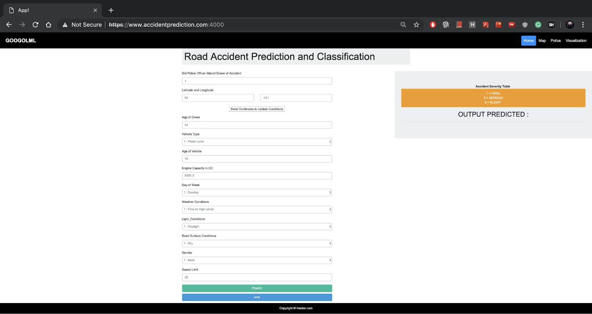

1. **Location and Weather Data Integration**
   * **GPS Location**:
     + Users can update their coordinates through a button, which uses the GeoLocation API to fetch and display real-time location data.

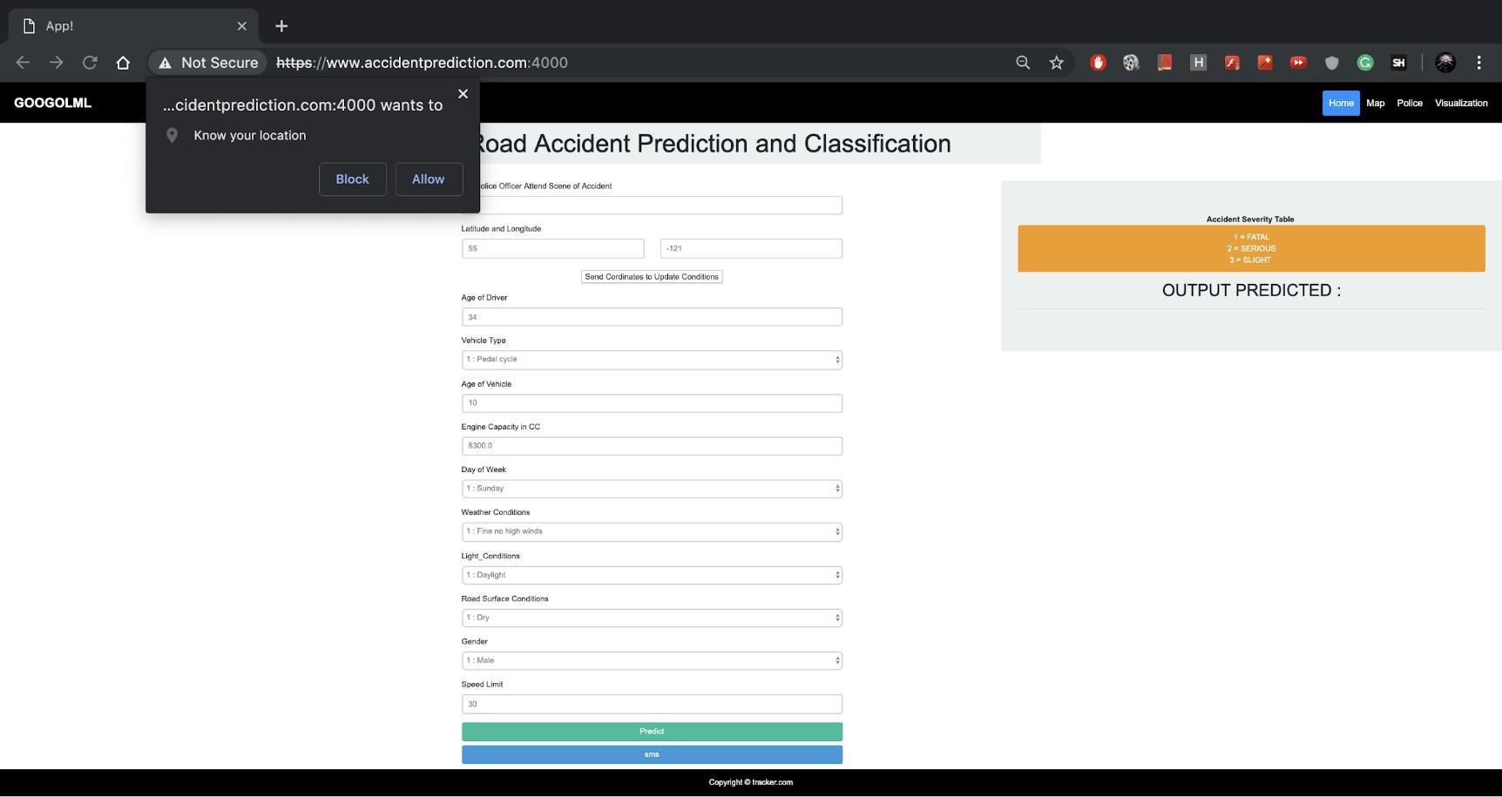

* + **Weather Conditions**:
    - After obtaining user coordinates, weather details are fetched from the OpenWeatherMap API, providing crucial context for accident prediction.

1. **User Input for Prediction**
   * **Input Parameters**:
     + Users input various parameters, including vehicle type, age, gender, and speed limit.

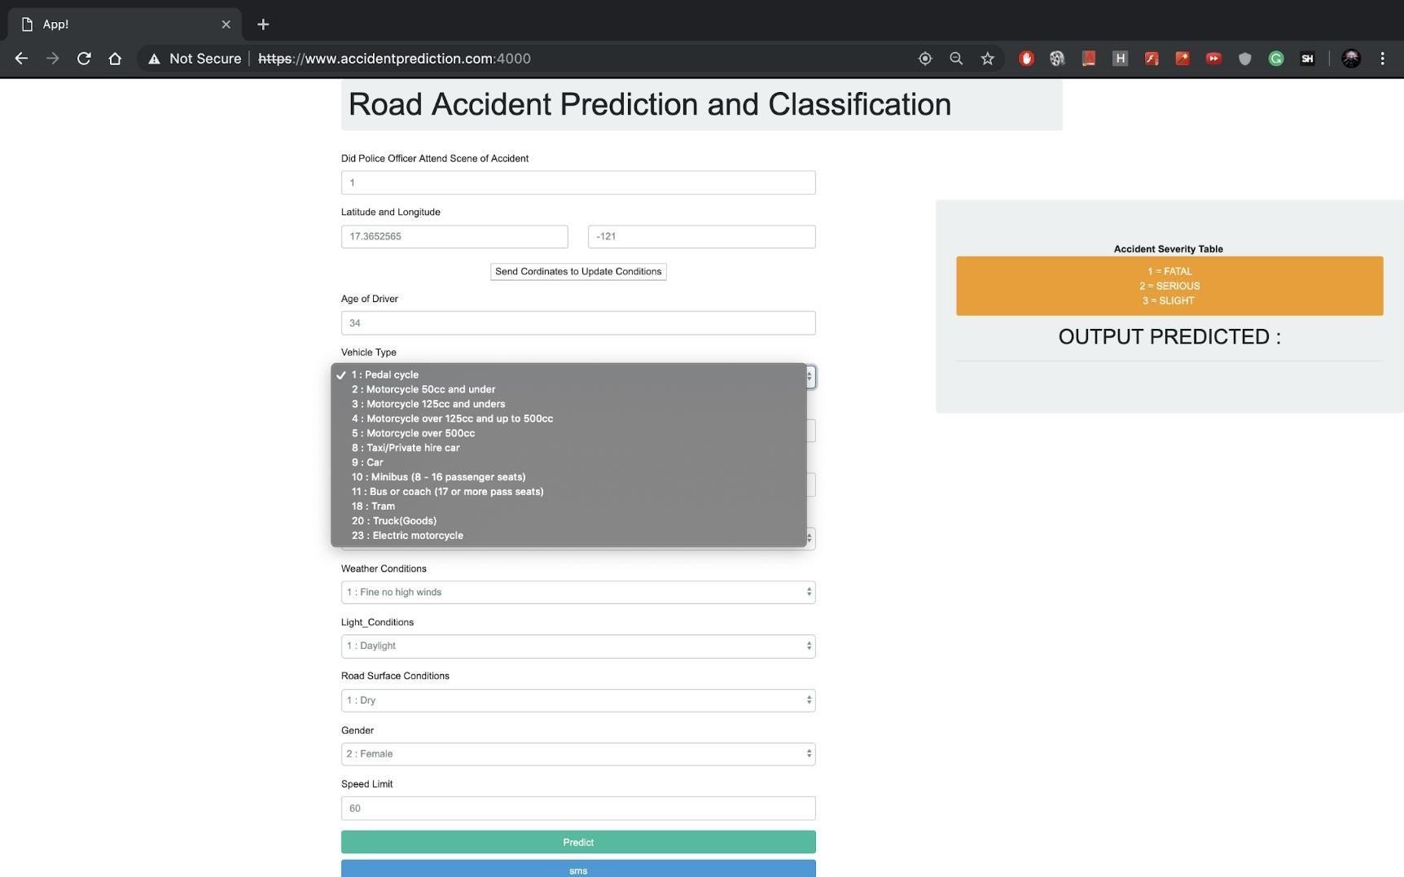

1. **Prediction Results**
   * **Output Prediction**:
     + Upon clicking the predict button, the model returns the predicted accident severity based on input parameters.

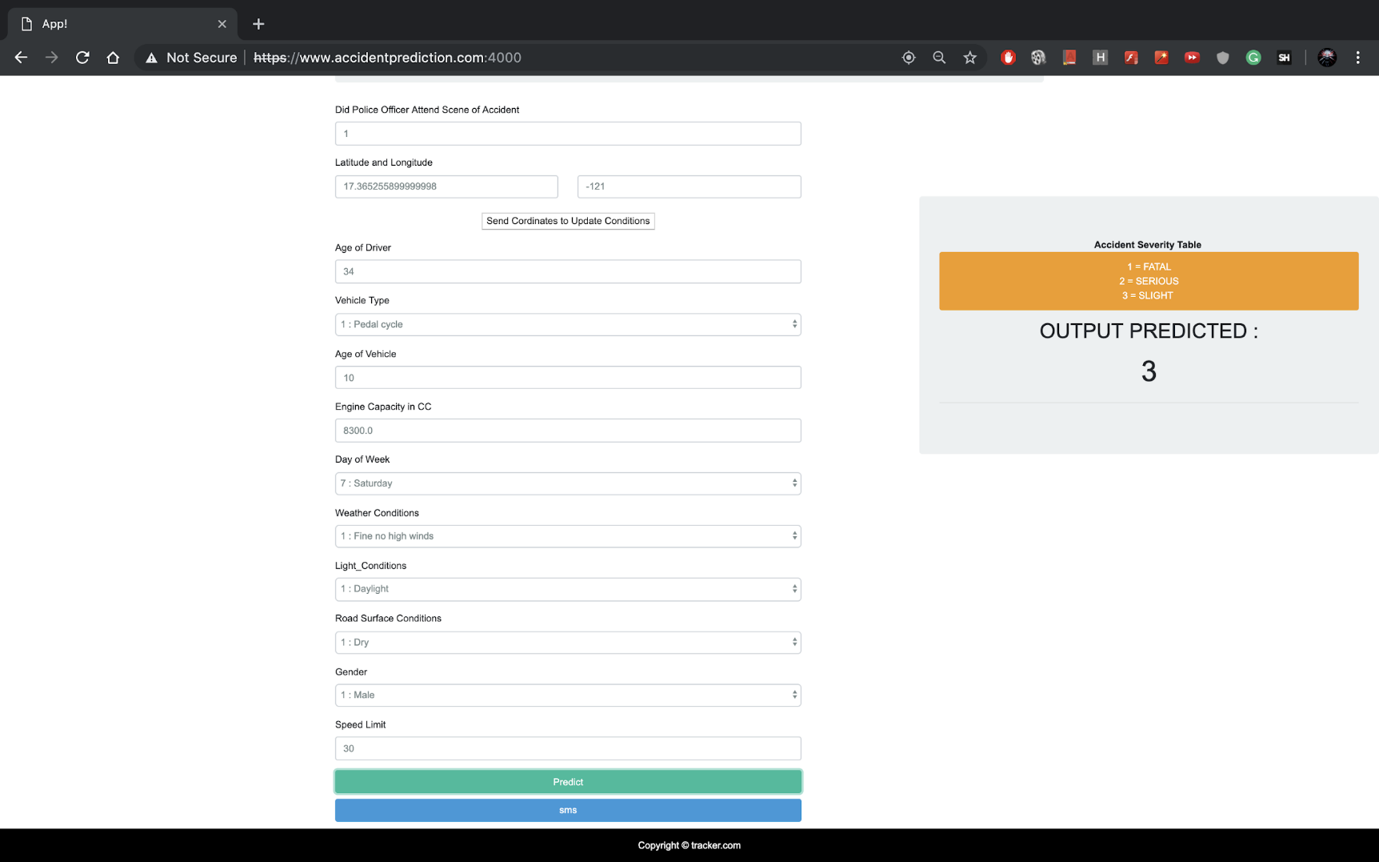

* + - **Severity Levels**:
      * 1 - Fatal
      * 2 - Severe
      * 3 - Slight

1. **Emergency Alert System**
   * **SMS Notification**:
     + An SMS alert is sent to local police with details of the user's location and predicted accident severity, leveraging the TextLocal API for notifications.

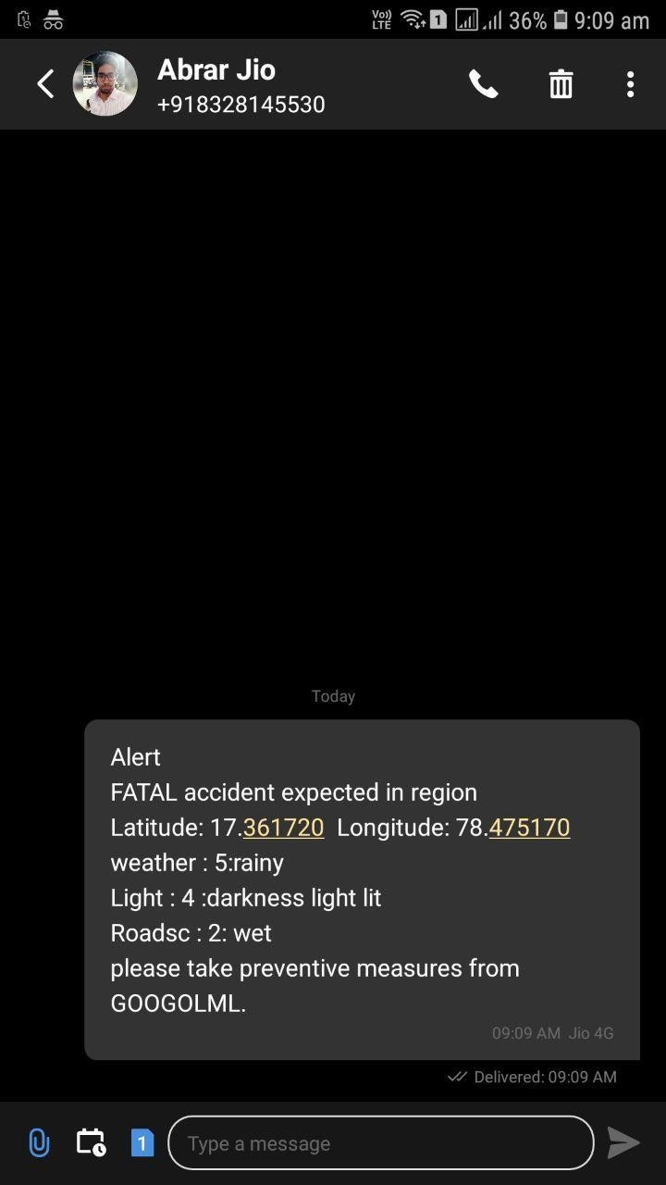

1. **Interactive Heat Map**
   * **Visualization of Accident Severity**:
     + An interactive heat map displays accident severity across different locations, utilizing the Google Maps API for visual representation.

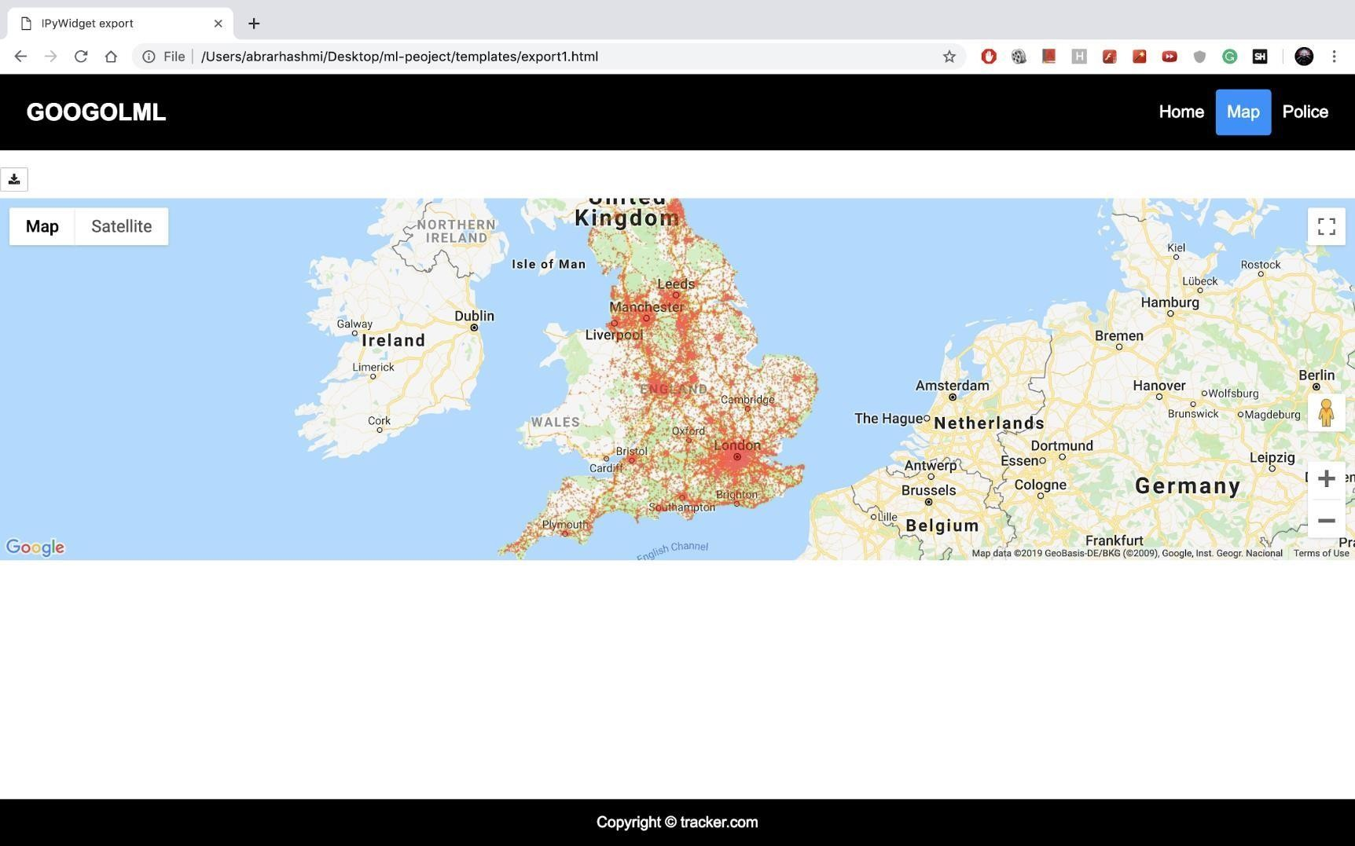

**CHAPTER – 7**

* 1. **CONCLUSION**

###### In conclusion, road accidents pose a significant threat to public safety and the economy. Machine learning offers a practical approach to predicting the severity of traffic accidents. The paper highlights the importance of accurate predictions in reducing the number of accidents and suggests using advanced machine learning techniques for this purpose

* 1. **FUTURE WORK**

For the future enhancement of the project titled "Road Accident Prediction Using Machine Learning," several avenues can be explored to further improve its functionality and usability.

1.Enhanced Real-Time Data Integration: Integrate real-time data sources such as traffic cameras, weather sensors, and vehicle telematics to provide up-to-date information on road conditions, weather patterns, and driving behaviors. This will improve the accuracy and timeliness of accident predictions, enabling proactive measures to be taken to prevent accidents. 2.Incorporation of Advanced Machine Learning Techniques: Explore advanced machine learning techniques such as deep learning, ensemble learning, and reinforcement learning to enhance the predictive capabilities of the models. Deep learning algorithms, in particular, can extract complex patterns and dependencies

from large datasets, leading to more accurate predictions of accident severity and occurrence

**CHAPTER - 8 REFERENCE**

[1].W. Long, Z. Lu, and L. Cui, “Deep learning-based feature engineering for stock price movement prediction,”

KnowledgeBased Syst., vol. 164, pp. 163–173, Jan. 2019

[2].Y. Zhang, B. Yan, and M. Aasma, “A novel deep learning framework: Prediction and analysis of financial time series using CEEMD and LSTM,” Expert Syst. Appl., vol.159, p. 113609, 2020

[3].X. Yuan, J. Yuan, T. Jiang, and Q. U. Ain, “Integrated Long-Term Stock Selection Models Based on Feature Selection and Machine Learning Algorithms for China Stock Market,” IEEE Access, vol. 8, pp. 22672–22685, 2020.

[4].M. Jiang, J. Liu, L. Zhang, and C. Liu, “An improved Stacking framework for stock index prediction by leveraging tree-based ensemble models and deep learning algorithms,” Phys. A Stat. Mech. its Appl., vol. 541, Mar. 2020.

[5].S. Ismail, M. S. MdNoorani, M. Ismail, F. Abdul Razak, and M. A. Alias, “Predicting next day direction of stock price movement using machine learning methods with persistent homology: Evidence from Kuala Lumpur Stock Exchange,” Appl. Soft Comput. J., vol. 93, Aug. 2020.

[6].Z. Lanbouri and S. Achchab, “Stock Market prediction on High frequency data using Long-Short Term Memory,” ProcediaComput. Sci., vol. 175, pp. 603–608, 2020.